IDE systems changes
The logo is flush on the left with the edge of the screen, add some padding on the left, so its inline with the logo in the footer.
The menu doesn’t look premium. Give me a pill box type menu similar to https://flintandfuel.github.io/hemels-cafe/
With a translucent blurred background.

The heading font could be hard to read on all sizes. I like the bold style, just give me a different font which is a bit more readable.

Since client doesn’t have any good images beyond generic stock images, lets liven the layout up with colour gradient sections, in the same style as the hero section, just different color schemes that compliment the current palette. So we alternate between light and dark section layouts with an extended color palette that is in harmony with the blue and orange, not too flashy or bright.
Start with the ‘Who it’s for’ section, using a dark themed background to reverse the colors, then also make the card backgrounds a very light transparent shade, so it’s a super premium feel.
Also change the colour of the results section ‘40+ years of SA banking system development” to the dark version.

Use a gradient in the TRACK RECORD section as well in addition to the blue background. And make the card backgrounds even lighter, so it feels premium.

Also use the orange as accent color in the footer, where it makes the most sense, either in the text or layout.

Also add in the footer “website design by Flint and Fuel Creative, with a hyperlink to Flintandfuel.co.za

Round 2
Header font:
I don’t like the new heading font, its too plain. Use the zen dots font for headings from google fonts, alternatively a wide font closer to the previous font we used. Also use the gradient coloring in a few more places in the layout.
Hero Section:
In the results section below the hero buttons I see 2 grey blocks? Are those placeholders?
I like the menu now, but not when it switches to white on scroll. Either keep it blue, or even a darker shade of blue, or don’t make it sticky.
The Problem section:
Remove Community banking image placeholder.

Core banking section:
Would it be tasteful to add small icons to the features sections here? Or would it break down the premium feel? Just think this section needs something to liven up the layout?

Who its for section:
Header font color is still dark so its not visible. Also the cards’ font color is still white so its not visible. Also add the subtle orange gradient similar to the hero section to the blue background.

40+ results section:
Still white, use the dark colouring

Deployment options section:
Make the cards the dark background color scheme

“TRACK RECORD” – make it the orange color

Free consultation section
The grey background doesn’t fit. Rather use another gradient background, maybe a different version of the blue and orange, or an orange and yellow gradient background

Move Website design by Flint and Fuel Creative to the bottom bar – as part of the copyright statement

Round 3
The heading font is still hard to read, try something cleaner, like Space Grotesk.

Move this text section up to underneath the header – currently it feels like a duplication:

40+
Years of SA banking
system development
656M+
Member deposits across
SA's CFI sector
2
Languages: English
and Afrikaans
Free
Initial consultation,
every time

Use a dark blue for the header fonts Instead of the black – it looks quite dead

Who its for

The text in the feature blocks is still white “cooperative financial institutions”

Compliance and security section:

Make these stand out more:

Cooperative Banks Act No. 40 of 2007
SARB Prudential Authority
FICA Compliant
CODI Aligned
POPIA Aligned
Full Audit Trail

Either by using the orange as background for each one, or make them blue with an orange outline

Deployment options section:

Some Text in the blocks still white

Track record section looks great

The free resource section looks great

FAQ section
Also make this left aligned to be inline with the rest of the site

Free consultation section
Use a similar style background as per the free resource section, just a different color combo for the gradient

Footer
Remove the PAXISS watermark.

Round 4

Take out this section in the header

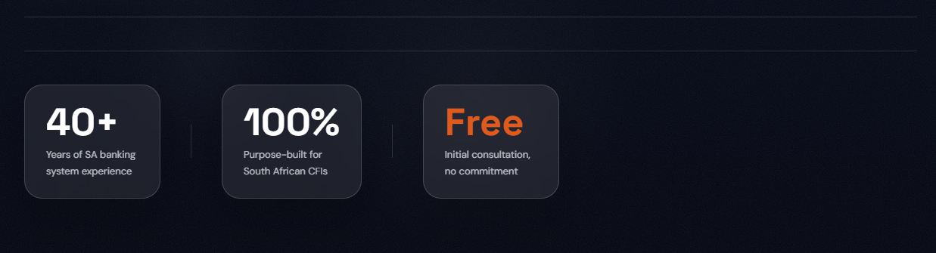
make the address and email text orange to stand out, as well as PLATFORM and GET STARTED text and remove the duplicate email on the right and the website address from the footer.

Text in the WHO ITS FOR section white blocks is still white:
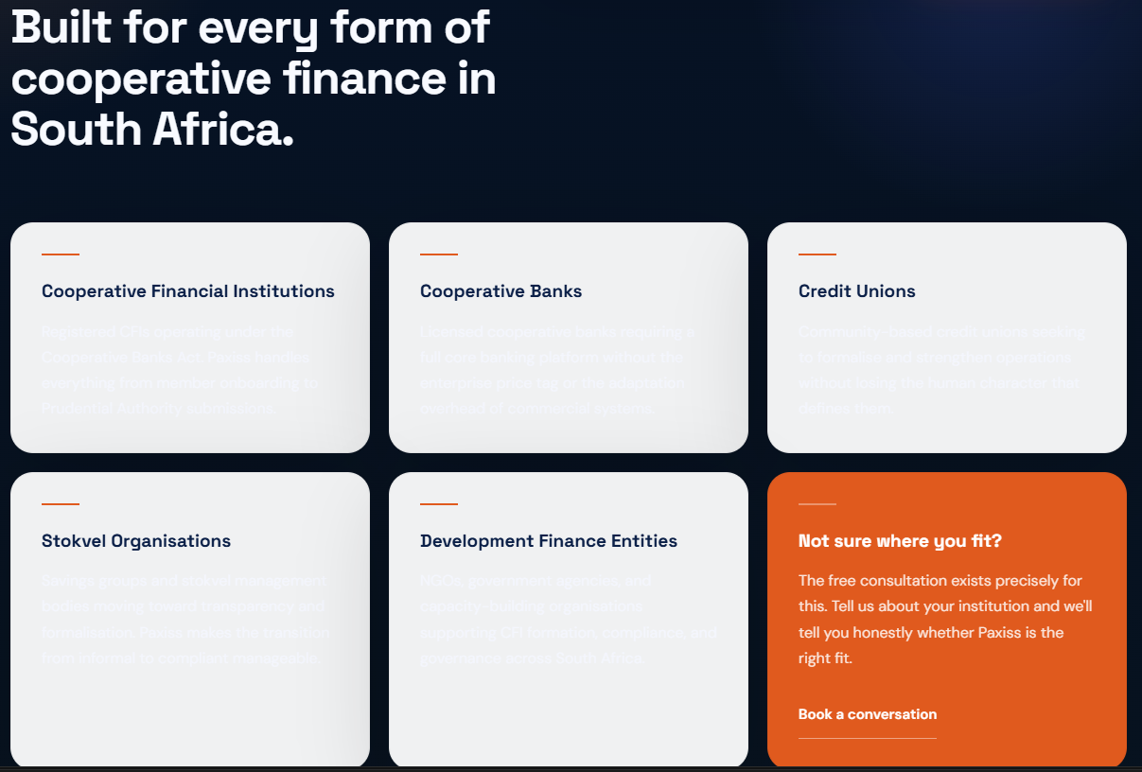

TRACK RECORD section
THE is hanging on the first line in desktop view. Rather move to second line.

FAQ section
Rather centre align again, looks weird like this

Footer
Make the contact details orange to stand out
Remove email and web address from GET STARTED section

Round 5
change FEATURES in menu to SOLUTIONS. Also change the menu hamburger breakpoint to a wider setting, the menu breaks weird on small screen size

reduce the section spacing above COMPLIANCE, since its 2 white sections, the gap is too much

